The Eurasia Proceedings of Science, Technology, Engineering and Mathematics (EPSTEM), 2026

Volume 40, Pages 202-210

ICBAST 2026: International Conference on Basic Sciences and Technology

Integrating Bayesian Inference with BP-Transformer for Accurate Traffic Flow Prediction

Anastasia Feofilova
Don State Technical University

Viacheslav Fialkin
Don State Technical University

Jixiao Jiang
Don State Technical University

Abstract: Nonlinear fluctuations and abrupt events in traffic flow can lead to significant point prediction errors, thereby limiting the effectiveness of traffic control strategies in Intelligent Transportation Systems (ITS). To address this issue, we propose a novel hybrid deep learning model, Bayes-BP-Transformer. This model combines Bayesian inference with backpropagation and a Transformer architecture, improving prediction accuracy while maintaining the model's generalization ability. Specifically, the backpropagation component captures local temporal patterns, while the Transformer encoder models long-range spatiotemporal dependencies. By introducing Bayesian inference, the model optimizes the probability distribution of network weights, improving robustness to noise and incomplete data. Experiments on two real-world traffic datasets demonstrate the superior performance of our model. Compared to advanced models, Bayes-BP-Transformer reduces the root mean square error (RMSE) by 18.6-38.0% and the mean absolute percentage error (MAPE) by 5.7-32.9%. Therefore, this model provides a feasible approach for building reliable prediction systems in ITS.

Keywords: Traffic flow prediction, Spatio-temporal modeling, Transformer, Intelligent Transportation Systems

Introduction

Traffic flow data, as a typical spatiotemporal sequence, is generated by the combined influence of road network topology, driving behavior, signal control, and various unforeseen events (Zhang et al., 2025). This convergence of multiple factors results in highly non-stationary and spatiotemporally heterogeneous traffic flow, posing a continuous challenge to accurate prediction. Single deep learning models, such as CNNs and their variants, cannot simultaneously capture the spatiotemporal dependencies present in the road network (Yang et al., 2025). Currently, complex deep learning models such as Temporal Convolutional Networks (TCNs) and Long Short-Term Memory Networks (LSTMs) have achieved extremely high prediction accuracy in various real-world prediction scenarios by precisely capturing the abrupt changes and temporal dependencies of traffic flow (Jiang et al., 2026). However, these models rely on large amounts of historical data for training (Topilin et al., 2025). When data is sparse or unconventional traffic patterns occur, their generalization ability often declines. Secondly, models like TCNs and LSTMs are essentially point prediction models (Wang et al., 2025). In scenarios where traffic flow fluctuates dramatically and exhibits non-linear changes, the prediction results are unreliable due to the lack of visualized prediction parameters, thus affecting the robustness of traffic control strategies

To address these challenges, researchers are attempting to incorporate optimization algorithms or attention mechanisms into the models to enhance the accuracy and interpretability of predictions (Dai & Tang, 2025). For example, Ali et al. (2025) record prediction accuracy by combining Gated Recurrent Units (GRUs) and Graph Convolutional Networks (GCNs) to record spatial and temporal variation characteristics. Wu et al. (2026) demonstrated that dynamic graph convolutional networks combined with attention mechanisms can effectively capture real-time changes in road network topology to achieve efficient prediction. Tian et al. (2025) analyzed the randomness of traffic flow at road intersections by fusing the Sparrow Search Algorithm (SSA) with the Deep Extreme Learning Machine (DELM) and finally obtained the best fitting effect in the experiment. However, these models generally exhibit a strong dependence on high-quality historical data. Furthermore, multi-module fusion models come with high computational costs. In real-world deployment scenarios requiring real-time responses, issues such as long training times and complex parameter tuning limit their practicality in road networks.

To overcome these limitations, we propose a novel hybrid deep learning model, Bayes-BP-Transformer. The BP component, a lightweight yet efficient module, extracts local temporal features. Compared to recurrent architectures like LSTM, the BP network offers lower computational overhead and faster training speed, making it more suitable for real-time deployments. The Transformer encoder captures long-range spatiotemporal dependencies through its multi-head self-attention mechanism. Unlike TCNs, which are limited by fixed receptive fields, the Transformer can dynamically weight the importance of different time steps and spatial locations, enabling more flexible modeling of complex traffic patterns. The Bayesian framework incorporates uncertainty into the learning process by setting probability distributions on the network weights instead of learning fixed values. The core innovation of Bayes-BP-Transformer lies in its seamless integration of deterministic feature extraction and inference. Pure Bayesian models often struggle to balance scalability and computational efficiency when applied to high-dimensional traffic data. Our method addresses this deficiency by embedding Bayesian layers within the BP-Transformer backbone, achieving a balance between representational power and uncertainty perception. This design ensures that the model remains computationally feasible in real-time applications, while providing more stable predictions under fluctuating traffic conditions.

Method

Overall Model Framework

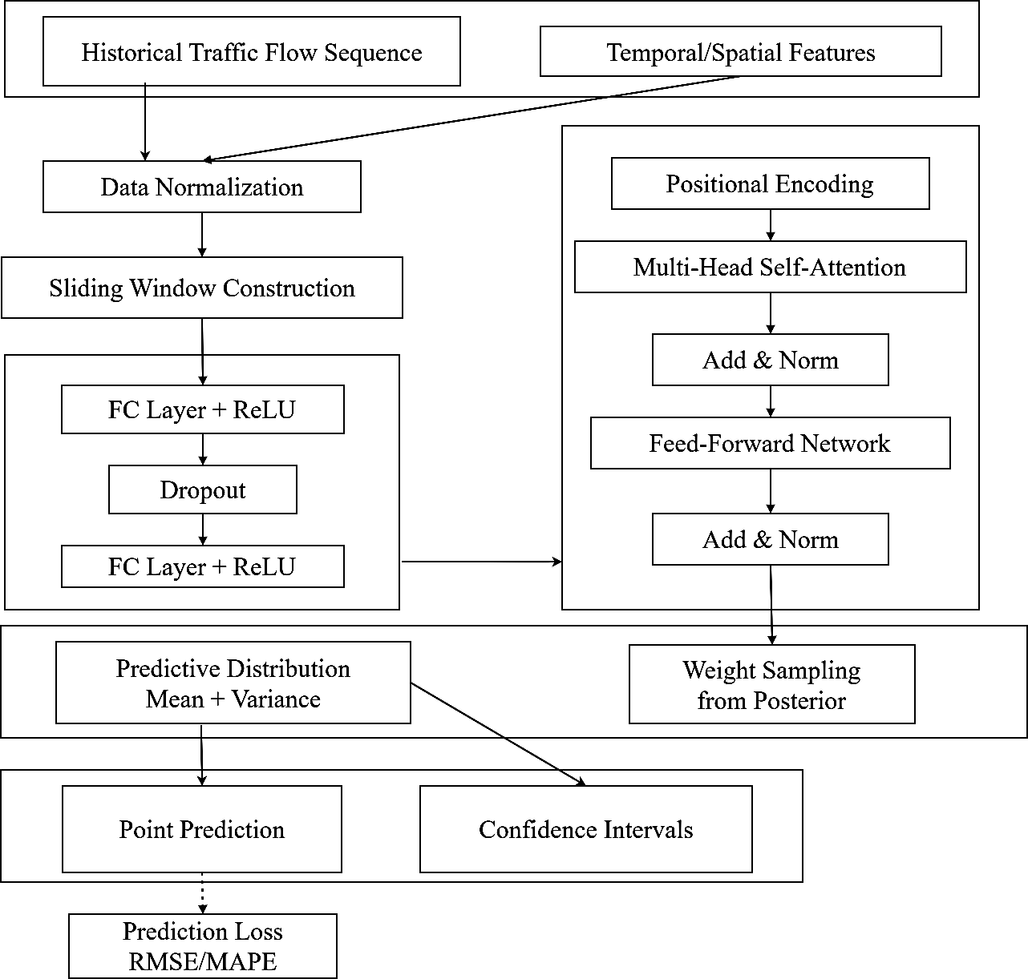
Figure 1. Bayes-BP-Transformer overall framework and process
The overall flow of the Bayes-BP-Transformer model is shown in Figure 1. Historical traffic flow sequences and spatiotemporal features are first normalized and input into the BP module, where local temporal features are extracted through two fully connected layers and Dropout operations. Subsequently, these features are fed into the Transformer encoder, passing through position encoding, multi-head self-attention mechanism, residual connections, and a feedforward network to dynamically model long-range spatiotemporal dependencies. The Transformer output enters the Bayesian inference layer, where the mean and variance of the predicted distribution are obtained by posterior sampling of the network weights. Finally, the model jointly optimizes the prediction error during training, improving the model's generalization ability while ensuring prediction accuracy.

BP-Transformer Module Modeling

The BP module is the first stage of the Bayes-BP-Transformer model, responsible for extracting local temporal features from the preprocessed input data. This module acts as a learnable input embedding layer, projecting raw traffic features into a high-dimensional space that facilitates subsequent temporal dependency modeling by the Transformer encoder.This module consists of two fully connected layers with a Dropout layer inserted in between to prevent overfitting, and each fully connected layer is followed by a ReLU activation function to introduce a nonlinear transformation. Let the traffic flow data input to the BP module be X, and the operation of flattening the input X into a vector x is represented by Equation 1.

 | $$x=\text{Flatten}\left(X\right)$$ | (1)

The computation of the first fully connected layer is represented by Equation 2.

 | $$h_{1}=\text{ReLU}\left(W_{1}x+b_{1}\right)$$ | (2)

where W₁ denotes the weight matrix, b₁ denotes the bias term, and ReLU denotes the activation function.

To mitigate overfitting in the BP module, Dropout is applied to the output of the first layer. This process is represented by Equation 3.

 | $$h_{1}^{drop}=\text{Dropout}\left(h_{1},p\right)$$ | (3)
where p denotes the neuron dropout probability.

The operation of the second fully connected layer of the BP module for further extracting traffic flow features is represented by Equation 4.

 | $$h_{2}=\text{ReLU}\left(W_{2}h_{1}+b_{2}\right)$$ | (4)

where W₂ denotes the weight matrix of the second fully connected layer, and b₂ denotes the bias term.

Finally, the BP module outputs the local temporal features obtained from the fully connected layer, which are then passed to the subsequent Transformer encoder for further processing. The operation flow of the Transformer encoder is shown in Figure 2.

The Transformer encoder consists of L identical layers stacked together. Each layer contains a multi-head self-attention mechanism and a feedforward network, with residual connections and layer normalization following each sub-layer. The calculation of the attention output of the Lth layer is shown in Equation 5.

 | $A=\text{softmax}\left(\frac{z_{0}W^{φ}⋅K^{T}}{\sqrt{d_{k}}}\right)⋅V$ | (5)

where z₀ denotes the Transformer's positional encoding, denotes the learnable weight matrix, T denotes the historical time steps, d denotes the dimension of each attention head, and K and V denote the attention weight matrices.

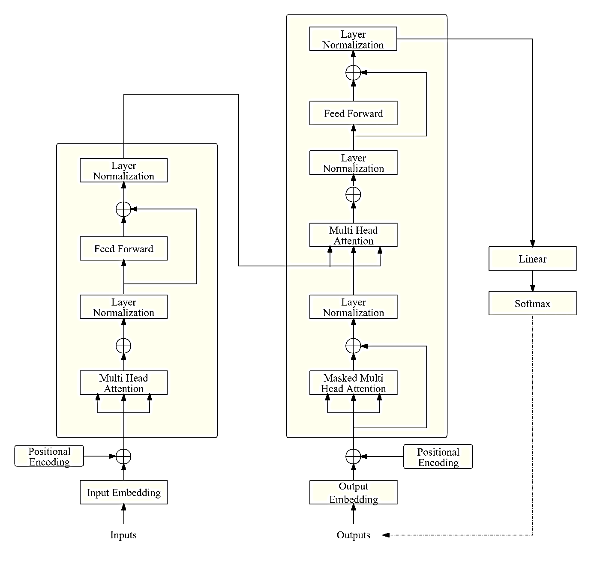
Figure 2. Transformer encoder operation flow

The subsequent operation of adding residual connections and layer normalization to the Transformer is represented by Equation 6.

 | $$z_{L}=\text{LayerNorm}\left(z_{L-1}+A\right)$$ | (6)

where denotes the output of the (L-1)th Transformer encoder, and LayerNorm denotes layer normalization.

After stacking L layers, the final output Z (Equation 7) serves as the spatiotemporal feature representation extracted by the Transformer encoder and is passed to the subsequent Bayesian inference module.

 | $$Z=\text{LayerNorm}\left(z_{L}+\text{ReLU}\left(W_{L}^{F_{1}}+b_{L}\right)⋅W_{L}^{F_{2}}\right)$$ | (7)

where and denote the feedforward network weight matrices, and denotes the bias of the feedforward network weight matrix.

Bayesian Inference Module Modeling

The Bayesian inference module treats network weights as probability distributions and learns the posterior distribution of weights through variational inference during training, thereby effectively alleviating the overfitting problem. Its operation process is shown in Figure 3.
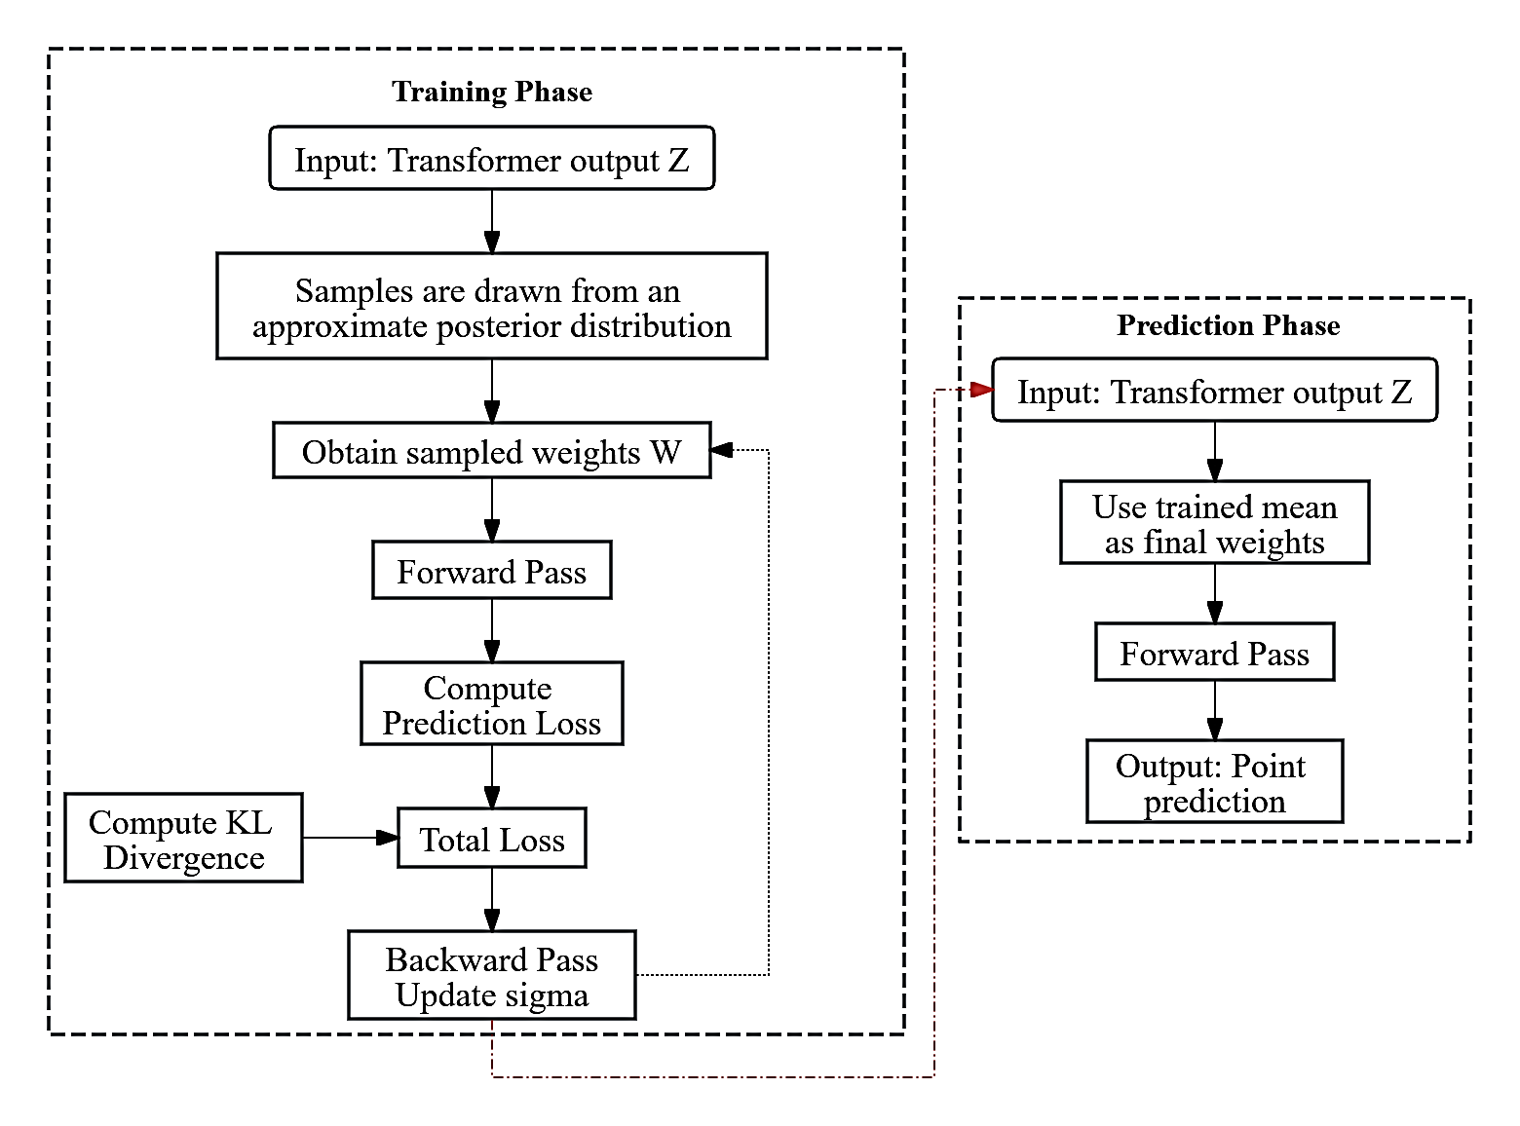
Figure 3. Bayesian inference module operation flow

The Bayesian module replaces traditional deterministic weights with probability distributions, where each weight is represented by the mean and log-variance (Equation 8).

 | $W_{T}=μ+\exp\left(ρ\right)⊙ε$ | (8)

where denotes the weight mean matrix, denotes the log-standard deviation parameter, and denotes standard normal distribution noise.

The approximate posterior distribution of the weights is defined by Equation 9.

 | $$q\left(W_{T}\left|μ,ρ\right.\right)=\prod_{ij}{N\left(W_{ij}\left|μ_{ij},{\exp\left(ρ_{ij}\right)}^{2}\right.\right)}$$ | (9)

where denotes the mean of the weights, and denotes the log-variance.

The expression for a single forward propagation is Equation 10.

 | $$y=δ\left(z⋅W_{T}+b\right)$$ | (10)

where denotes the activation function, and b denotes the deterministic bias term.

The total loss function is defined as Equation 11.

 | $$L=\frac{1}{N}\sum{\left(y_{i}-{\hat{y}}_{i}\right)}+\sum{\frac{\left(μ^{2}+\exp\left(2ρ\right)-1-2ρ\right)}{2}}$$ | (11)

where $\sum{\left(y_{i}-{\hat{y}}_{i}\right)}$ denotes the KL divergence term, yᵢ denotes the true value of the i-th sample, and denotes the predicted value of the i-th sample.

The entire model prediction output stage is represented by Equation 12.

 | $\hat{y}=z⋅μ^{T}+b$ | (12)

where denotes the transpose of the mean matrix μ.

The three core modules of the Bayes-BP-Transformer model are connected in a serial cascade manner to form an end-to-end prediction framework. The modules work collaboratively to achieve a complete mapping from raw data to prediction results.

Prediction Experimental Verification

Experimental Data Selection

The experiments in this study were conducted in the MATLAB environment, utilizing its deep learning toolbox to construct, train, and validate the Bayes-BP-Transformer model. Both datasets used in the experiments were derived from a publicly available traffic flow database (UTD). The Paris long-term dataset was collected from 1-hour aggregated data from detector number 268 throughout May 2016, while the Turin short-term dataset was collected from 5-minute aggregated data from detector number 2255 on September 27, 2016.

The Paris dataset was chosen because the full-month, long-term data allows for thorough validation of the model's ability to capture multi-scale periodic dependencies. Detector 268, located on a core Parisian artery, experiences high and complex traffic flow patterns, placing higher demands on the model's generalization ability. Furthermore, the mixed patterns of numerous holidays and workdays in May allow for testing the model's robustness under unconventional traffic conditions.

The Turin dataset was chosen because short-term single-day data can be used to verify the model's predictive performance under limited historical data conditions, simulating data-sparse scenarios in real-world applications. Furthermore, Turin, as a medium-sized city, has traffic flow characteristics that differ from Paris, which helps test the model's cross-city transferability.

Traffic Flow Prediction Experiment

To objectively assess the model's level within existing research and provide a quantifiable benchmark for future studies, we compared it with the baseline model BP, as well as two advanced models: CNN-LSTM (Zhang et al., 2025) and GRU-Attention (Li et al., 2025). Figure 4 shows the data prediction results for detector 268 for each model.

(a) BP prediction results | (b) CNN-LSTM prediction results
(c) GRU-Attention prediction results | (d) Bayes-BP-Transformer prediction results
Figure 4. Prediction results of different models on detector No.268

As shown in Figure 4, in the traffic flow prediction task of detector 268, the Bayes-BP-Transformer model performed best, while the BP model performed worst. This is because the BP model, as a single fully connected network, can only capture the static mapping relationship between input features. It cannot effectively model the temporal dependencies and dynamic changes in traffic flow data. The Bayes-BP-Transformer model, on the other hand, integrates the dynamic modeling of long-range spatiotemporal dependencies of the Transformer and adjusts the loss parameters through Bayesian inference, thus improving the model's generalization ability under complex traffic patterns. Figure 5 illustrates the process of adjusting the model's loss function through Bayesian inference.

Figure 5. Loss function adjustment process

As shown in Figure 5, Bayesian inference achieves the best prediction results by automatically finding the optimal loss function and effectively suppressing overfitting during training through KL divergence regularization.

Results and Discussion

To more intuitively compare the prediction accuracy of each model, we used RMSE and MAPE as evaluation metrics to assess the prediction data obtained by detectors 268 and 2255 (Jiang & Feofilova, 2025). The evaluation metrics for the prediction results are shown in Table 1.

Table 1. Evaluation metrics results for various models
Detector number | Model | RMSE | MAPE
No.268 | BP | 41.279 | 45.840
No.268 | CNN-LSTM | 35.827 | 37.644
No.268 | GRU-Attention | 28.523 | 30.131
No.268 | Bayes-BP-Transformer | 22.195 | 28.427
No.2255 | BP | 44.128 | 47.015
No.2255 | CNN-LSTM | 37.603 | 39.280
No.2255 | GRU-Attention | 30.127 | 34.092
No.2255 | Bayes-BP-Transformer | 24.521 | 26.355

As shown in Table 1, the BP model performed the worst on the Paris dataset. CNN-LSTM improved performance through local feature extraction. GRU-Attention further enhanced prediction accuracy by introducing an attention mechanism. The proposed Bayes-BP-Transformer model achieved the best results across all metrics, reducing the RMSE by 22.2% compared to GRU-Attention. On the Turin dataset, the model performance ranking remained consistent, with Bayes-BP-Transformer again performing best, reducing RMSE by 18.6% and 22.7% compared to the second-best models, respectively. This advantage further demonstrates the Transformer's ability to capture long-range spatiotemporal dependencies, the robustness of Bayesian inference to noise, and the effective suppression of overfitting by KL divergence regularization.

Conclusion

This paper proposes a Bayes-BP-Transformer hybrid deep learning model for accurate and robust traffic flow prediction. This model combines Bayesian inference with a BP-Transformer backbone network, effectively capturing local temporal patterns and long-range spatiotemporal dependencies, and introduces probability weight distribution to enhance generalization ability and noise resistance. Experiments on two real-world datasets from Paris and Turin demonstrate that the proposed model consistently outperforms baseline models and advanced models, including BP, CNN-LSTM, and GRU-Attention. Specifically, depending on the dataset and the comparison models, the Bayes-BP-Transformer reduces the root mean square error (RMSE) by 18.6% to 38.0% and the mean absolute percentage error (MAPE) by 5.7% to 32.9%. Therefore, the Bayes-BP-Transformer provides a feasible and reliable method for building robust prediction systems in ITS applications.Despite its advantages, the model has certain limitations. The current architecture does not explicitly incorporate spatial graph structures, which may limit its performance in complex road networks. Additionally, the choice of prior distributions in the Bayesian layers remains an open area for further exploration.

Recommendations

Future research can extend this work in several directions. First, introducing GCN to explicitly model spatial dependencies in road network topology can further improve prediction performance. Second, exploring different prior distributions of Bayesian layers, such as slab-flat priors, can improve the sparsity and interpretability of the model. Third, applying the proposed framework to other spatiotemporal prediction tasks, such as travel time prediction or traffic speed prediction, can further validate its generalization ability. Finally, deploying the model into a real traffic management system and evaluating its impact on control strategies will help to gain a deeper understanding of its practical application effectiveness.

Scientific Ethics Declaration

* The authors declare that the scientific ethical and legal responsibility of this article published in EPSTEM journal belongs to the authors.

Conflict of Interest

* The authors declare that they have no conflicts of interest

Funding

* No financial support or funding has been received from any public, private, or non-profit organization for the research, authorship, and/or publication of this study.

Acknowledgements or Notes

* This article was presented as an oral presentation at the International Conference on Basic Sciences and Technology ( www.icbast.net ) held in Konya/Türkiye on April 02-05, 2026.

References

Ali, A., Ullah, I., Ahmad, S., Wu, Z., Li, J., & Bai, X. (2025). An attention-driven spatio-temporal deep hybrid neural networks for traffic flow prediction in transportation systems. IEEE Transactions on Intelligent Transportation Systems, 26(9), 14154–14168.
Dai, G., & Tang, J. (2025). A short-term traffic flow prediction method based on personalized lightweight federated learning. Sensors, 25(3), 967.
Jiang, J., & Feofilova, A. (2025). Traffic flow prediction: A hybrid VMD-NRBO-BiLSTM model approach. In 2025 13th International Conference on Traffic and Logistic Engineering (ICTLE) (pp. 198–203). IEEE.
Jiang, J., Feofilova, A., Topilin, I., & Liu, C. (2026). A novel attention-weighted VMD-LSSVM model for high-accuracy short-term traffic prediction. IET Intelligent Transport Systems, 20(1), e70144.
Li, W., Sun, Z., & Wan, Y. (2025). Spatio-temporal multi-graph convolution traffic flow prediction model based on multi-source information fusion and attention enhancement. Applied Sciences, 15(20), 11295.
Rezvanov, V. K., Romakina, O. M., & Zaytseva, E. V. (2025). Forecasting delivery time of goods in supply chains using machine learning methods. Advanced Engineering Research (Rostov-on-Don), 25(2), 120–128.
Tian, X., Wu, S., & Xing, X. (2025). Traffic flow prediction based on improved deep extreme learning machine. Scientific Reports, 15(1), 7421.
Topilin, I., Han, M., Feofilova, A. A., & Beskopylny, N. A. (2025). Comparative analysis of neural network and machine learning models for short-term traffic flow prediction on Shenzhen expressway. Advanced Engineering Research (Rostov-on-Don), 25(4), 350–362.
Topilin, I., Jiang, J., Feofilova, A., & Beskopylny, N. (2025). Traffic flow prediction via a hybrid CPO-CNN-LSTM-attention architecture. Smart Cities, 8(5), 148.
Wang, C., Huang, S., & Zhang, C. (2025). Short-term traffic flow prediction considering weather factors based on optimized deep learning neural networks: BO-GRA-CNN-BiLSTM. Sustainability, 17(6), 2576.
Wu, Z., Liu, X., & Zhang, X. (2026). Dynamic graph convolutional recurrent network with attention mechanism for traffic flow forecasting. Engineering Applications of Artificial Intelligence, 170, 114236.
Yang, S., Wu, Q., Li, Z., & Wang, K. (2025). PSTCGCN: Principal spatio-temporal causal graph convolutional network for traffic flow prediction. Neural Computing and Applications, 37(13), 14751–14764.
Zhang, J., Sha, J., Zhang, C., & Zhang, Y. (2025). A CNN-LSTM-GRU hybrid model for spatiotemporal highway traffic flow prediction. Systems, 13(9), 765.
Zhang, Y., Xu, W., Ma, B., & Li, X. (2025). Linear attention based spatiotemporal multi graph GCN for traffic flow prediction. Scientific Reports, 15(1), 8249.

Author(s) Information
Anastasia Feofilova  Don State Technical University  1, Gagarin Square, Rostov-on-Don, Russia  ORCID iD: https://orcid.org/0000-0003-3351-4246  *Contact e-mail: feofilowa@mail.ru | Viacheslav Fialkin  Don State Technical University  1, Gagarin Square, Rostov-on-Don, Russia  ORCID iD: https://orcid.org/0000-0003-4332-9677
Jixiao Jiang
Don State Technical University
1, Gagarin Square, Rostov-on-Don, Russia
ORCID iD: https://orcid.org/0009-0009-4376-790X
*Corresponding author(s) contact email

To cite this article:
Feofilova, A., Fialkin, V. & Jiang, J. (2026). Integrating Bayesian inference with BP-transformer for accurate traffic flow prediction. The Eurasia Proceedings of Science, Technology, Engineering and Mathematics (EPSTEM), 40, 202-210.

